Minimization of DFA

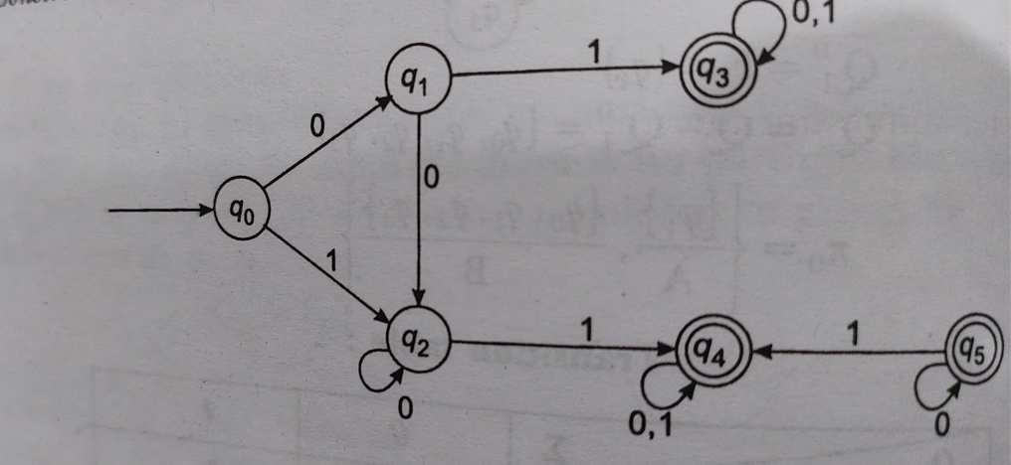

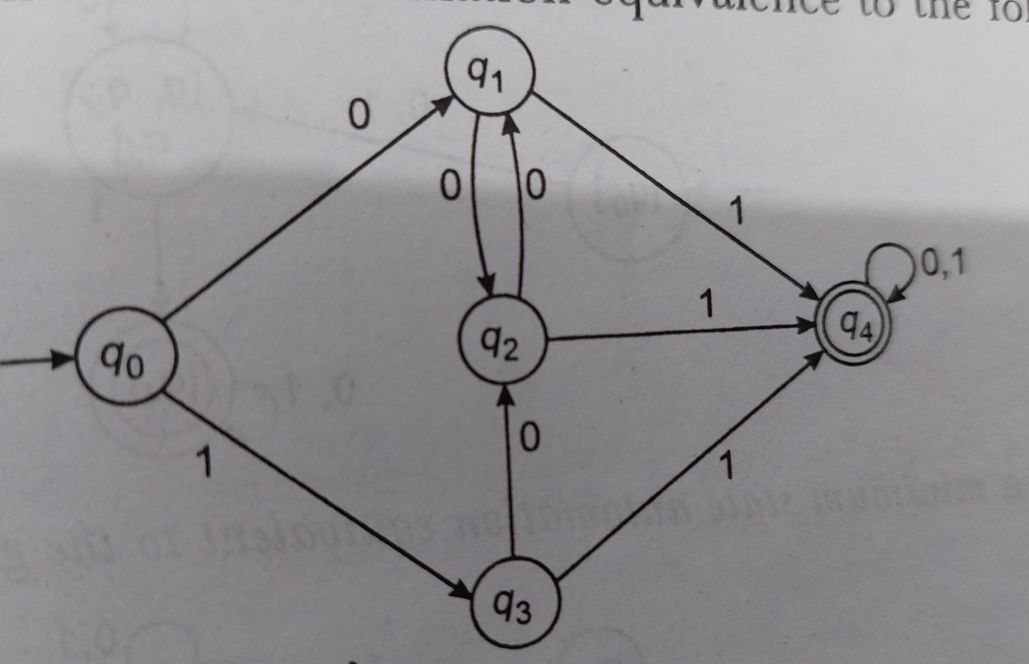

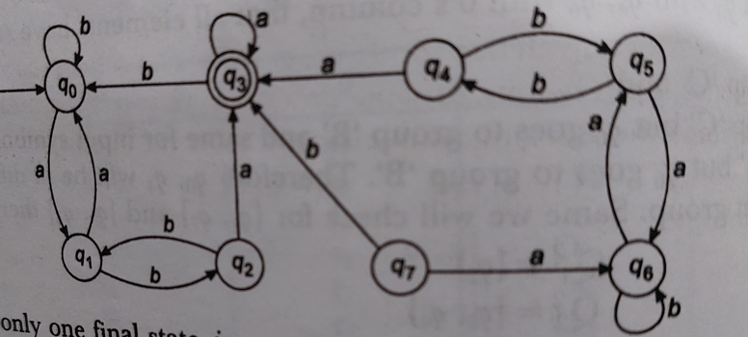

**Mealy and Moore Machine**

1. Design a Moore machine that will read sequence made up of letters a,e,I,o,u and will give as output same character except when an ‘I’ is followed by ‘e’ ,it will be changed to ‘u’ .Also design Mealy machine for the above problem.
2. Design a Moore machine that gives an output ‘1’ if input of binary sequence a ‘1’ is preceded by exactly two zeros.
3. Consider a Moore machine, construct a Mealy machine equivalent to this Mealy machine.

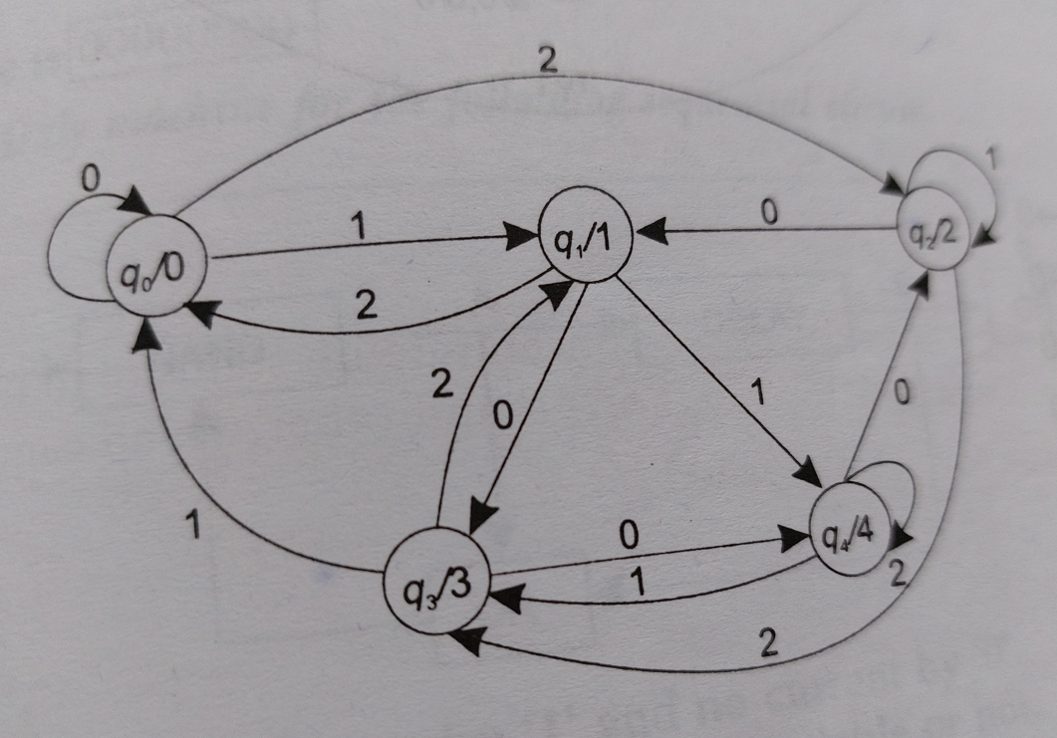

1. Consider a Mealy machine, construct a Moore machine equivalent to this Mealy machine.

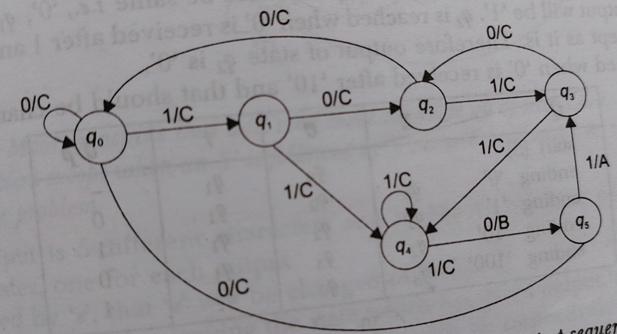

1. Construct Transition table of given Moore machine.



1. Construct Transition table of given Mealy machine.



**Pumping Lemma**

1. Show that L = a^n b a^n is not regular with pumping lemma.
2. Show that L = a^n b^n c^n d^2n is not regular.
3. Show that L= a (b)*a is not regular.
4. Show that L= a^n b^n is not regular.